ASE Lab 3 Report

Rajesh Gupta Kollipara (Class Id:21)

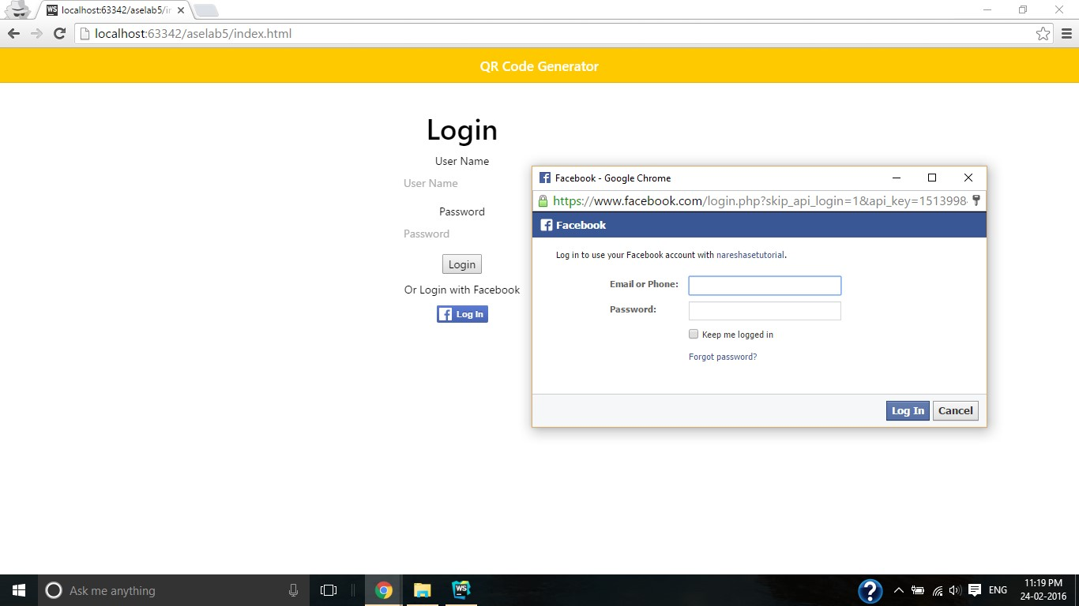

On Successful Login, admin.html will be open !!

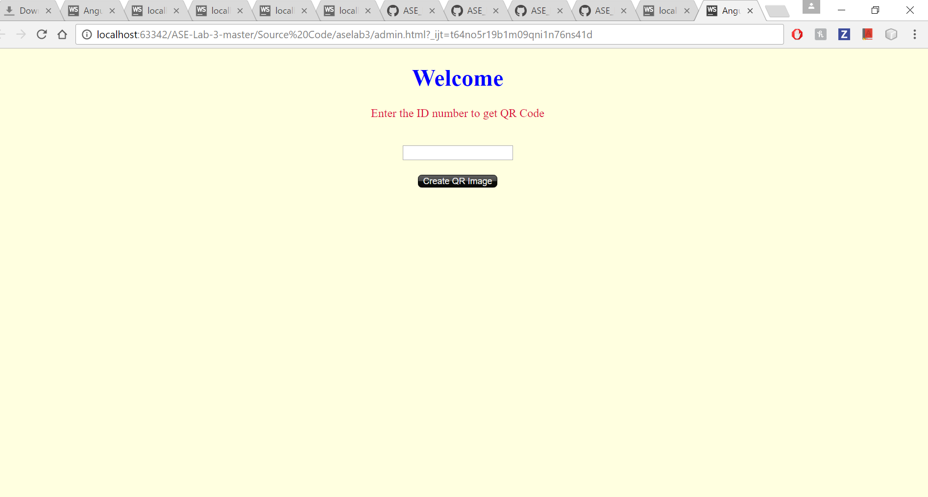

[**https://api.qrserver.com/v1/create-qr-code/?data=giventext**](https://api.qrserver.com/v1/create-qr-code/?data=giventext) **will fetch QR image**

